**PHASE 4**

**LESSON 2**

**PRACTICE ASSISTED 4**

**Source code:**

Map.html:

<!DOCTYPE html>

<html lang="en">

<head>

    <meta charset="UTF-8">

    <meta http-equiv="X-UA-Compatible" content="IE=edge">

    <meta name="viewport" content="width=device-width, initial-scale=1.0">

    <title>Document</title>

</head>

<body>

    <script>

        var map =  new Map;

        map.set(101,"Vaishu");

        map.set(102,"Kav");

        map.set(103,"Kalps");

        map.set(104,"Pranesh");

        map.set(105,"Dhivi");

        map.set(106,"HK");

console.log(map);

console.log("Has: "+map.has(103));

        console.log("Get: "+map.get(102));

        console.log("Delete: "+map.delete(106));

        console.log(map);

        map.clear();

        console.log(map);

    </script>

</body>

</html>

OUTPUT:

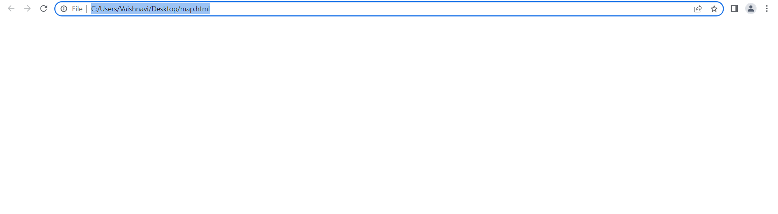

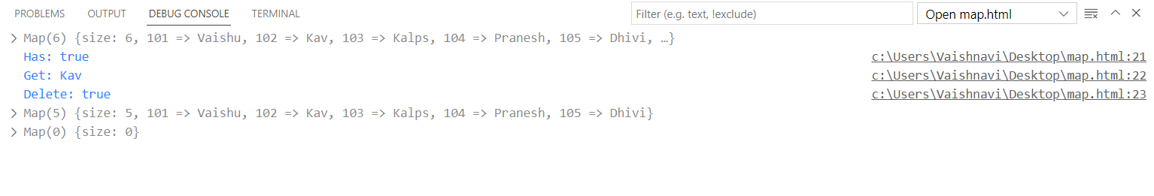

Class.html:

<!DOCTYPE html>

<html lang="en">

<head>

    <meta charset="UTF-8">

    <meta http-equiv="X-UA-Compatible" content="IE=edge">

    <meta name="viewport" content="width=device-width, initial-scale=1.0">

    <title>Document</title>

</head>

<body>

    <script>

        class Student{

            constructor(id, name){

                this.id = id;

                this.name = name;

            }

            display(){

                console.log("ID: "+this.id);

                console.log("Name: "+this.name);

            }

        }

//object creation

var s1 = new Student(1,"Vaishu");

        var s2 = new Student(2,"Kav");

  //display

s1.display();

        s2.display();

    </script>

</body>

</html>

OUTPUT:

